UPI FRAUD DETECTION

A Capstone Project report submitted
in partial fulfilment of requirement for the award of degree

BACHELOR OF TECHNOLOGY
in
SCHOOL OF COMPUTER SCIENCE AND ARTIFICIAL INTELLIGENCE
By

A HARSHINI (2203A52134)
G JEEVAN (2203A52150)
B MANISAI (2203A52136)
S PAVAN KUMAR REDDY (2203A52177)
U VIGNESHWARA CHARY (2203A52184)

Under the guidance of
Dr. N VENKATESH
Assistant Professor, School of CS&AI.


SR University, Ananthsagar,Warangal,Telagnana-506371

SR University
Ananthasagar, Warangal.



CERTIFICATE
This is to certify that this project entitled “UPI FRAUD DETECTION" is the bonafied work carried out by A HARSHINI,G JEEVAN,S PAVAN,U VIGNESHWARA CHARY,B MANISAI as a Capstone Project for the partial fulfillment to award the degree BACHELOR OF TECHNOLOGY in School of Computer Science and Artificial Intelligence during the academic year 2024-2025 under our guidance and Supervision.

Dr.N.Venkatesh Dr. M.Sheshikala Assistant Professor, Professor & Head,
School of CS&AI School of CS&AI, SR University SR University Ananthasagar, Warangal. Ananthasagar, Warangal.

Reviewer-1 Reviewer-2
Name: Name:
Designation: Designation:
Signature: Signature
ACKNOWLEDGEMENT
We owe an enormous debt of gratitude to our Capstone project guide Dr.N.Venkatesh, Asst.Prof as well as Head of the School of CS&AI , Dr. M.Sheshikala, Professor and Dean of the School of CS&AI, Dr.Indrajeet Gupta Professor for guiding us from the beginning through the end of the Capstone Project with their intellectual advices and insightful suggestions. We truly value their consistent feedback on our progress, which was always constructive and encouraging and ultimately drove us to the right direction.
We express our thanks to project co-ordinators Mr. Sallauddin Md, Asst. Prof., and R.Ashok Asst. Prof. for their encouragement and support.
Finally, we express our thanks to all the teaching and non-teaching staff of the department for their suggestions and timely support.

CONTENTS
S.NO | TITLE | PAGE NO.
1, | ABSTRACT | 1
2, | ABOUT THE ORGANIZATION OR COMPANY | 2
3, | INTRODUCTION OF PROJECT | 2
4, | RELATED WORK | 3-4
5, | PROBLEM STATEMENT | 4-5
6, | REQUIREMENT ANALYSIS, RISK ANALYSIS, FEASIBILITY ANALYSIS | 5-7
7, | PROPOSED SOLUTION OR APPROACH / TECHNIQUE | 7-10
8, | ARCHITECTURE DIAGRAMS, FLOW CHART, DFD | 10-13
9, | SIMULATION SETUP AND IMPLEMENTATION | 13-16
10, | RESULT COMPARISON AND ANALYSIS | 17-22
11, | LEARNING OUTCOME | 22
12, | CONCLUSION WITH CHALLENGES | 22-23
13, | REFERENCES | 23-24

LIST OF FIGURES

Fig No. | TITLE | PAGE NO.
1 | Architecture Diagram | 11
2 | Data Flow Diagram | 12
3 | Flow chart | 13
4 | Homepage UI | 18
5 | User Login Page UI | 19
6 | Detector Tool Interface | 19
7 | Prediction Result (Real) | 20
8 | Prediction Result (Fake) | 20
9 | Model Training & Validation Accuracy Graph | 21

LIST OF TABLES

Table No. | TITLE | PAGE NO.
1 | Risk Analysis | 6-7
2 | Feasibility Analysis | 7
3 | Technology Stack | 10
4 | Data Composition | 14
5 | Model Hyperparameters | 15

List of Acronyms
Acronym | Full Form
AI | Artificial Intelligence
API | Application Programming Interface
CNN | Convolutional Neural Network
CSS | Cascading Style Sheets
DB | Database
Flask | A Python Web Framework
HTML | HyperText Markup Language
HTTP | Hypertext Transfer Protocol
JSON | JavaScript Object Notation
ML | Machine Learning
OCR | Optical Character Recognition
OpenCV | Open Source Computer Vision
PII | Personally Identifiable Information
PyTorch | An Open Source Machine Learning Library
SQL | Structured Query Language
SQLite | A Software Library for Embedded SQL Databases
UI | User Interface
UPI | Unified Payments Interface
URL | Uniform Resource Locator
UTR | Unique Transaction Reference

ABSTRACT
The described project, UPI-SHIELD, is a full-stack web application that aims at fighting the extremely important and increasingly significant problem of the digital payment fraud through the use of the forged UPI screenshots. This type of social engineering fraud takes advantage of the operational requirement that merchants and users have to rely on quick visual confirmation to the detriment of the traditional bank-side security that is unaware of this type of attack. To combat this we developed a hybrid system of detection. It is the only system to use two potent methods: (1) a Convolutional Neural Network (CNN), a fine-tuned MobileNetV3, to find subtle visual artifacts and anomalies, including pixel noise, compression errors, and font inconsistencies, to identify digital tampering, and (2) an Optical Character Recognition (OCR) engine to logically validate the extracted text (e.g., UTR format, date validity). This two (visual + logical) guard is very strong.

Training CNN in PyTorch was done on a custom dataset, which was built by accumulating real screenshots, anonymizing them, and subsequently faking them programmatically under OpenCV. The use of this entire AI engine is in a secure, multi-page Flask web application. The program is built on an architecture of 3-tier and includes a full user authentication system, including registration and login, created using Flask-Login, SQLAlchemy to manage the database and Bcrypt to securely hash passwords. The Bootstrap 5 used on the frontend provides a friendly, responsive, and professional experience to the user. The resultant deliverable is a secure, end-to-end application that offers clients a prompt and dependable Real or Fake verdict that offers a practical and essential defense against this prevalent fraud.

ABOUT THE ORGANIZATION
This project was carried out under the School of Computer Science and Artificial Intelligence, SR University, Ananthasagar, Warangal.
SR University is recognized for its research-driven curriculum, interdisciplinary problem-solving approach, and strong emphasis on innovation and technology-driven projects. The institution provides students with modern laboratory facilities, high-performance computing resources, and access to cloud-based platforms such as Google Colab, which were extensively used for implementing this project.
1.INTRODUCTION OF PROJECT
1.1 Background
Unified Payments Interface (UPI) has turned out to be a game changer to the digital economy in India and has made mobile payment real-time, 24/7. Nonetheless, this revolutionary achievement has also brought about a new and destructive security vulnerability of social engineering. More often, scammers take advantage of the fast speed and trust nature of such transactions by showing merchants fake payment screenshots. Merchants become extremely susceptible to this fraud in places where people are likely to have many transactions, e.g., cafes, retail stores, taxis, etc.
This poses a serious security gap that is not capable of being solved by current solutions. The modern bank-side fraud detection systems are advanced and they are used to scan network-level information to detect abnormalities such as high transaction speed, geographic location or high-value transfer to thwart extensive-scale fraud. But these high-tech systems are actually blind to this social engineering attack; they cannot notice the fake screenshot displayed to the merchant. It is not the network that fails but the human to human contact that is founded on the visual trust.
Our project, UPI-Shield is aimed to seal this particular gap by offering a realistic, real-time, and effective verification tool. Our solution is a developed Hybrid Detection Engine. It is not based on just one approach.

- First, it is based on a Convolutional Neural Network (CNN) fine-tuned MobileNetV3 model, trained at PyTorch. This AI is trained to view the image as a digital forensic investigator, identifying the small and insidious visual evidence of the actions of image editing software, including incongruent compression blocks, unnatural pixel noise, and font discrepancies, which cannot be seen by the human eye.
- Secondly, it uses an Optical Character Recognition (OCR) engine. This element will read the text on the screenshot (as the UTR number and date) and make a logical validation check. A scammer may produce a fraudulent artificially beautiful copy, but this verification may detect logical inconsistencies, e.g. a invalid UTR format or future date of transaction.
1.2 Problem Statement
The Indian economy has been transformed by the Unified Payments Interface (UPI). It has also helped to transform the manner in which transactions are carried out, whether it is in large-scale e-commerce or in the street-side stall, due to its ability to facilitate instant, 24/7 and low-cost payments of any amount digitally. This rapid use has been a major move towards a less-cash society. Yet, this quick development, as well as convenience, has also brought with it new and harmful vectors of fraud, which do not attack the network but the point of human presence.
This type of scam is the most widespread and dangerous, and the use of fake payment screenshots. In the given case, a scammer makes a payment to a service or a product and provides the merchant with a screenshot of a successful payment screen which has been digitally manipulated. These counterfeits that are usually made with the help of basic mobile editing programs are quite often persuasive.
This poses a significant weakness to merchants operating in high-traffic places that require real-time (e.g. cafes, small stores, or taxi drivers) and are unable to pause and enter their bank application to manually verify the UTR number in every transaction. It means a security gap that current systems fail to close because of their reliance on rapid and purely visual confirmation:
- Bank-Side Systems are Blind: Conventional fraud detection is network-based; it is searching after suspicious patterns of transactions. It is not able to observe the social engineering attack that is taking place in the real world between the fraudster and the trader.
- Human Verification is Ineffective: The pace and amount of transactions in UPI make it practically unfeasible to check and verify every payment made by a merchant manually and particularly at peak times.
This weakness is actively utilized, which causes the direct losses of merchants and a major breach of trust in the system of digital payments. This project is being called UPI-Shield with the aim of directly solving this particular, unmitigated problem.
1.3 Project Objective
The main aim of this project, which is UPI-Shield, is to design, develop, and implement a secure, interactive, and highly accurate full stack web application that can be used to battle UPI screenshot fraud. It is not just a mere classifier but an end-to-end system. The following are the main objectives:
- To Build a Resilient Hybrid AI Model: The overall technical objective is to create a Hybrid Detection Engine which is no longer based on simple visual analysis. This involves:
- CNN (Visual Check): Training and developing a Convolutional Neural Network (MobileNetV3) on top of PyTorch to identify the visual artifacts (e.g., pixel noises, compression errors, font fading, etc.) that digital editing usually leaves behind.
- The OCR (Logical Check): Installing a Optical Character Recognition (OCR) engine to read the text on the screen (e.g. the UTR number and date) and check it logically (e.g. are the UTR number and date valid).
- Custom Dataset Generation: To aid in it, one of the main tasks is the generation of a proprietary training dataset through the collection, anonymization and programmatic forging of fake screenshots with the help of OpenCV.
- In order to design a safe full-stack application: The AI model needs to be encased in a secure, browser-compatible platform. This task is to develop a 3-layer application, whereby Flask will be the backend server to store the AI models and a secured API and Bootstrap 5 will be the front-end framework.
- To Introduce Strong User Authentication: A full-fledged authentication system is necessary to ensure security of the application and control user access. This will involve installing a SQLite database using SQLAlchemy, user-registration/user-login pages and use Flask-Login to control the user sessions and use Bcrypt to hash all user passwords in a safe manner.
- To Deliver a Final and Unambiguous Warranty: The last user-facing goal will be to make the tool practical. The system has to combine the outputs of the CNN and the OCR tests into one, almost instant, and simple to comprehend system of Real or Fake. This will enable the user to make data-driven and confident decisions on a real-time basis and seal the security gap.
1.4 Scope of the Project
This project will involve the entire lifecycle of end-to-end development of the application of the UPI-Shield, which entails data collection to an end-to-end web application that is secure.
Originally, the data coverage comprises the background of the AI. It entailed the hand-gathered collection of a set of various real UPI screenshots of different payment apps (GPay, PhonePe) and different devices (Android/iOS) to use as a ground truth baseline. This was followed by a process of critical data anonymization directly and the Personally Identifiable Information (PII) was redacted to ensure the privacy of the users.
The programmatic generation of a very large fake dataset with OpenCV was used to augment this dataset to construct a strong classifier. The script was created in such a way that it would introduce some visual tampering (noise, hue shifts) and content/logical tampering (fake text, invalid UTRs) to train our hybrid model.
The model scope is twofold, covering the creation of our Hybrid AI Engine.
- CNN (Visual Analysis): This involved selecting, training, and evaluating a MobileNetV3 deep learning model. We used PyTorch and transfer learning to fine-tune this model, which yields the saved upi_model.pth file. Its purpose is to detect visual artifacts of forgery.
- OCR (Logical Analysis): This involved implementing the Tesseract OCR engine to extract all text from the image. We then wrote a rule-based validation script to check this text for logical impossibilities (e.g., invalid UTR format, future dates).
The backend scope covers the development of the server-side "engine" of the application using Flask. This includes the full user authentication system: user registration with secure password hashing via Bcrypt, user login, and session management via Flask-Login.
It also includes the management of the SQLite database (site.db) through SQLAlchemy for storing all user accounts. Critically, this scope covers the creation of the protected /predict API endpoint, which receives the user's image and orchestrates the "fusion" of the results from both the CNN and OCR models to produce a single, final verdict.
Finally, the frontend scope covers the complete user-facing experience. This includes the development of a multi-page, responsive website using HTML5, CSS3, and Bootstrap 5 for a professional look and feel. It involves the creation of all Jinja2 templates (base.html, index.html, login.html, register.html, profile.html, and detector.html).
This scope also includes the client-side JavaScript used on the detector page, which utilizes the fetch() API to communicate with the backend's /predict API and display the final "Real" or "Fake" alert to the user without a page reload.

2. RELATED WORK
2.1 Overview of UPI Fraud Techniques
The ease of use and omnipresence of UPI, although its biggest strength, form a certain and notable weakness. The criminal activities have changed since the bank-side network security has been enhanced. The literature and the popular news reports are indicating that fraud is becoming less network-level focused (attacks such as exploiting encryption) and more high-success social engineering-focused scams. It is a strategy that avoids all the technical security and attacks the weakest link of the chain of transactions: the human user.
Transaction screen forgery is the most common and effective method which is directly dealt with in this project. Some of the ways through which scammers do this have been designed:
- Direct Image Editing: A scammer captures an image of a past and valid transaction in the form of a screenshot using standard software, such as Photoshop or mobile image editing software. They consequently suture or modify the picture to alter important information such as the name of the recipient, the amount paid and the Transaction ID (UTR).
- Dedicated Prank Apps: More advanced approach will be dedicated prank payment apps. These apps are made to completely replicate the user experience of other popular apps such as GPay or phone pe. All a scammer has to do is enter any name and any amount, and the application produces an appearance that a payment has succeeded, which, visually, is the same as the real one, including a fake processing animation.

2.2 Existing Fraud Detection Systems
The majority of the existing and massive fraud detection systems, as outlined in the literature about banking and financial technology, are at the network or server level. These systems are extremely advanced but they are not to confirm person to person visual authentications but rather are meant to safeguard the security of the financial net itself.
Transaction monitoring and behavioral analytics are the two key technologies used in these systems to alert suspicious activity. As an example, they may apply machine learning models to identify the anomalies in:
- Velocity: A sudden increase in the high-value transfers (transfers) of an account compared to the historical average in a given account.
- Geometry: A transaction which has its source at a geographical point that is unfamiliar to the user.
- Time: Transactions are made at unusual times (e.g., 3 AM).
- Recipient: A user has unexpectedly transferred a huge amount of money to an unknown recipient that was recently added.
Although these systems are very effective in detecting unauthorized access to the account, identity theft, or money laundering performed in large scales, they are totally unaware of the social engineering attack that our project is focused on.
The essential weakness is that such systems process transaction data (the request), but not visual artifacts (the proof). They do not have any access to the screenshot displayed on the phone of a scammer. On the side of the bank, nothing ever was initiated in the form of a transaction hence no fraud is identified.
They can ensure that a transaction did not occur by checking manifested by the merchant logging in, but cannot prevent a merchant believing it occurred by an availed fake screenshot. This puts the merchant as the only uncovered link in this particular chain of fraud.
2.3 Machine Learning for Image Forgery Detection
The field of digital forensics provides the core technical foundation for our project. While classic methods like Error Level Analysis (ELA) exist, they are often slow and require expert interpretation. Therefore, our project leverages a more state-of-the-art Deep Learning approach, specifically using a Convolutional Neural Network (CNN).
Transfer learning was used instead of constructing a model. We chose MobileNetV3, which is a powerful and lightweight CNN, which had been pre-trained on millions of images and fine-tuned it using the PyTorch framework. MobileNetV3 is focused on the high efficiency that made it an ideal solution when it comes to loading a web application fast. With just a few refinements on our own custom set of real and forged UPI screen shots, the model will be taught to automatically perceive and recognize the difficult to detect visual artifacts that digital editing applications leave behind. This includes:
- Irregular noise patterns of pixels.
- Incompatible JPEG compression levels.
- Artificial outlines or halos around spliced text.
Nonetheless, a CNN only verifies visual defects. The scammer might be so professional that he or she might make a fake so visual that it might pass a CNN. In order to deal with this, in our project we introduce a stronger Hybrid Model.

3. PROBLEM STATEMENT
UPI has been a game-changing force for the Indian economy in that it enables any-time, 24x7, low-cost digital payments. Its rapid adoption has been a significant step toward a "less-cash" society. This rapid growth has also brought in new vectors for fraud.
A common and harmful scam exists in the form of fake payment screenshots: Some scammer "pays" for something using a digitally altered screenshot of a "payment successful" screen. Such fakes may look pretty convincing, and merchants in high-traffic environments (for example, cafes, small shops, or taxi drivers) will never have the time to stop and individually verify every transaction's UTR number in their bank application. This reliance on fast visual-only confirmation creates a huge vulnerability. There is merchant fraud-the theft of goods and services-and a loss of confidence in the digital payment ecosystem. This project tackles this critical gap in security.

4. REQUIREMENT ANALYSIS, RISK ANALYSIS, AND FEASIBILITY ANALYSIS
4.1 REQUIREMENT ANALYSIS
4.1.1 FUNCTIONAL REQUIREMENTS
User Registration: The system shall provide the means for a new user to create a secure account with a unique username and password.

- User Authentication: The system shall permit a registered user to log in and log out securely.

- Session Management: It should be able to keep track of sessions-whether a user is logged in or out.

- Access Control: Detector tool and profile pages should not be available to users who are logged out.

- Profile Viewing: Users who log in should see their profile information, such as a username or user ID.

- Image Upload: The system should provide an interface for uploading an image file by a logged-in user, such as JPG or PNG.

- Image Analysis: The uploaded picture needs to be processed using the image trained AI model.

- Display Verdict: The system has to return and display a clear, binary "Real" or "Fake" verdict, along with a confidence score.

    - NON-FUNCTIONAL REQUIREMENTS

- Security (Authentication): Passwords must never be stored in plain text. They must be hashed with a robust hashing algorithm, for instance Bcrypt.

- Security - API: The API endpoint for predictions (/predict) should be secure and accessible only to authenticated users.

- Performance: Prediction time for the model should be near instantaneous, in under 1 second to ensure a good user experience.

- Usability: The interface should be clean, modern, and intuitive, with no special training required by a new user.

- Responsiveness: A full responsive website, working properly in both desktop and mobile browsers will be achieved via Bootstrap 5.

- Handling: The system should be fault-tolerant, e.g., a user does not upload an image file or does not upload a file at all.

- Maintainability: The code must be modular, separating backend logic in Flask, frontend templates in HTML, and styling in CSS.

  - Risk Analysis
Risk ID | Risk Category | Risk Description | Likelihood | Impact | Mitigation Strategy
R-1 | Technical | Model Inaccuracy(False Negative): The model incorrectly classifies a fake screenshot as real. | Medium | High | Implement a hybrid model (add OCR) for a second check.
R-2 | Technical | Model Inaccuracy(False Positive): The model incorrectly classifies a real screenshot as fake. | Medium | Medium | Train the model on a more diverse dataset, including low-quality or blurry real images. And clearly stating the confidence score.
R-3 | Security | User Data Breach: The site.db file is compromised, exposing user data. | Low | High | Use Bcrypt to ensure all passwords are hased. Even if the DB is stolen, passwords are not readable. And enforce strong password policies.
R-4 | User | Over-reliance: A user trusts the tool 100%, ignores a “Fake” warning, or gets a “False Negative”(R-1) and loses money. | High | High | Adding a clear disclaimer in the UI stating this is an educational tool and not a substitute for bank confirmation. Use prominent red/green alerts.
R-5 | Operational | Server Overload: If the app becomes popular, the Flask development server cannot handle concurrent users. | High | Medium | For a real-world deployment, do not use the development server.

  - Feasibility Analysis

Types of feasibility | Analysis | Result
Technical | All required tools (Python, Flask, PyTorch) are open-source and freely available. | Feasible
Operational | The web app is intuitive (Login, Upload, Verdict) and requires no special training. | Feasible
Economic | Zero monetary cost; all software and frameworks are free and open-source. | Highly  Feasible
Schedule | All project phases (data collection, training, web dev) were completed within the academic timeline. | Feasible
Legal | Uses open-source libraries. User privacy is protected (anonymized data, hashed passwords). | Feasible

5. PROPOSED SOLUTION OR APPROACH

Our solution is a full-stack, AI-powered web application. The development was split into two key pipelines: (A) creating the dataset and (B) building and training the model that powers the application.

5A. DATA PREPROCESSING & PIPELINE
The most critical component for any deep learning model would be a high-quality, representative dataset. Since no public dataset was available for "fake UPI screenshots," primarily due to the private and sensitive nature of financial data, we were required to compile our own. This custom dataset and the pipeline built to process it are core contributions of this project.
- Data Collection: Our initial step involved gathering a filtered base dataset of over 50 actual UPI payment successful screenshots. These were gathered across a variety of sources, including the most popular payment apps (GPay, PhonePe) and the various mobile operating systems (Android, iOS) which use different fonts and UI rendering to ensure that the final model would be robust and not overfit to one layout.

- Anonymization: This was an important ethical and technical procedure. All screen shots obtained received a comprehensive hand process to erase any Personally Identifiable Information (PII). This contained names, phone numbers, UPI IDs as well as unique transaction IDs (UTRs). This was done to serve two purposes: (a) It satisfied our ethical need to ensure privacy of the users, and (b) It was an essential technical measure to avoid data leakage, as the goal of our model was to learn to recognize forgery artifacts instead of memorizing one particular name or UPI ID of a person.

- Data Augmentation (Fake Data Generation): To generate a dataset large enough to be useful in deep learning, we picked the 50+ anonymized real images as a base to generate by program more than 250 fake images. This 1:5 ratio of real to the fake images assists in training the model on the minority (the fakes). Our Python script was based on the OpenCV library and was used to simulate two main forgery methods:

- Visual Tampering: This was made to appear to imitate a substandard edit or re-saving object. The script has added noise of the camera sensors (with the help of np.random.normal) or noise of low-quality re-upload, and alteration of hues randomly (with the help of cv2.cvtColor) to imitate distortion of colors.
- Content Tampering: This mimicked the most used form of fraud a direct content edit. The script had an algorithmic opaque black box (with cv2.rectangle) which was centered on the original amount of the transaction. After which, it milled a new randomized faked amount with this box (with cv2.puttext). This conditions the CNN to identify the visual features of the process of splicing or pasting new objects onto an image, like unnatural hard edges and compression discrepancies.

- Pipeline (PyTorch): A custom PyTorch Dataset class and DataLoader were used to load the final group of images (Real-Label 0, Fake-Label 1). Each image (both training and validation) was subjected to a transforms.Compose pipeline and then inputted into the model:
- Scale: All the images have been resized to have the same dimensions of 224x224 pixels. This is the input dimension required to use the MobileNetV3 architecture.

- ToTensor: PIL objects (the values of pixels, 0-255) were transformed into floats tensors (0.0-1.0), the required format to use on the GPU.
- Normalize: The images were made normalized with the help of standard mean and standard deviation ([0.485, 0.456, 0.406], [0.229, 0.224, 0.225]). It is an important step in transfer learning because it guarantees that the input images are statistically similar to the ImageNet original dataset, in which the MobileNetV3 model was pre-trained.
5B. MODEL ARCHITECTURE, TRAINING & EVALUATION
Model Architecture
At the center of our visual detector lies a Convolutional Neural Network (CNN). The main problem was to choose the architecture not only true to detecting forgeries of subtle nature but also one that is lightweight and sufficiently fast to be used in a real-time web application. A model that takes 10 seconds to give a verdict would be of no use to a merchant when he is in a hurry.
- Base Model: This is why we selected MobileNetV3 (Small). It is a state of the art lightweight CNN. It has specifically been built to be used in applications with large bandwidth and low latency (such as mobile and web) through advanced algorithms such as inverted residuals and squeezy-and-excite blocks. This performance is essential to the user experience of our project that guarantees an immediate decision. The model represents the graphical analysis part of our hybrid engine.
- Transfer Learning: We used a transfer learning model, which is significantly more efficient and fast compared to training a model by itself. We loaded the MobileNetV3 model which had been trained on ImageNet data set (a dataset of more than 14 million images). This enabled us to harness the given, strong, existing, base knowledge of model of low-level image features such as shape, edges, textures, fonts etc. We simply frozed the weights of these initial feature-extraction layers, as they are already professionals to see.
- Model Modification (Fine-Tuning): We substituted the last layer of the pre-trained MobileNetV3 with a classifier. The initial classifier that makes predictions of 1000 ImageNet classes (such as dog, cat, car, etc.) did not apply to our task. In PyTorch, model.classifier was substituted with our own custom nn.Sequential block. The new head is a full-connected layer (nn.Linear), an activation function (nn.Hardswish), a nn.Dropout layer to stop overfitting and after all, a new nn.Linear output layer with only 2 classes, which are "Real" and "Fake". The action makes the strong, already trained model more specific and narrow in a single task.
Training
The training phase is where the modified MobileNetV3 model "learns" to differentiate between real and fake screenshots from our custom dataset.
- Framework & Environment: The model was trained using the PyTorch deep learning library. We executed the training in a Google Colab environment to leverage its free GPU (Graphics Processing Unit) hardware. Using a GPU is essential for deep learning as it can perform the thousands of matrix calculations required for training exponentially faster than a standard CPU.
- Process (Train/Validation Split): Before training, the full dataset was randomly split into two parts: an 80% training set and a 20% validation set.
- The training set (80%) is the data the model actively learns from.
- The validation set (20%) is held back and used as an "unseen" test after each epoch. This is critical to ensure the model is generalizing and not just "memorizing" the training images. If training loss decreases while validation loss increases, it's a clear sign of overfitting.
- Hyperparameters: These are the settings we configured to guide the training process:
- Loss Function: nn.CrossEntropyLoss. This is the industry-standard loss function for binary or multi-class classification tasks. It effectively measures how "wrong" the model's predictions are compared to the true labels (0 for Real, 1 for Fake).
- Optimizer: optim.Adam. We chose the Adam optimizer because it is highly efficient and combines the advantages of other optimizers (like AdaGrad and RMSProp). It automatically adjusts the learning rate for each parameter during training, which typically leads to faster convergence.
- Learning Rate: We set an initial learning rate of 0.001.
- Epochs: The model was trained for 15 epochs, meaning it saw the entire training dataset 15 times.
- Batch Size: We used a batch size of 32. This means the model processed 32 images at a time, calculated the average loss for that batch, and then updated its weights.
- Training Loop: The 15-epoch training loop consisted of two main phases in each cycle. First, model.train() was called, and the model iterated through all batches of the training data, performing the forward pass (making a prediction), calculating the loss, backpropagation (calculating the gradients), and optimizer step (updating the model's weights). Second, model.eval() was called to switch the model to evaluation mode, and it iterated through the validation set to calculate the val_loss and val_accuracy, which were printed at the end of each epoch. The final, trained model weights were then saved as upi_model.pth.

Evaluation
Evaluation process played the important role of ensuring that the model was valid and not merely memorizing the training data but truly learnt to generalize. After every epoch, we measured the performance of the model with the help of validation set (20 percent of the data on which the model had not been trained).
Quantitative Assessment: Two important measures were monitored during training:
- Validation Loss: This was a measure of how wrong the model was in the case of the unseen data. We have seen that this value was gradually getting lower, and this shows that the model was becoming increasingly certain and precise.
- Validation Accuracy: This was a measure of percentage of correct prediction. The model showed a consistent increase in accuracy of validation over the training reaching up to over 95 percent.
The tendency of improving training and validation accuracy simultaneously proved that the model was indeed generalizing its knowledge. It was not merely memorizing the training images but it was acquiring the features behind a forgery. The last model obtained high accuracy in the validation and it showed that it has learnt to differentiate between real and fake screenshots in our dataset. These data were plotted to representation of learning curve.
Qualitative Evaluation: In addition to the quantitative measures, we also conducted live, qualitative testing during our flask application. We posted different screen shots (real and fake) which did not belong to the original data. The model was also able to distinguish between the two categories accurately and reliably flagging fakes and passing real screenshots, which was a confirmation of its ability to work in practice.
The last, validated model weights were then saved on the upi model.pth file. This is the file which is our brain or the already trained intelligence which is loaded by our Flask server to do live prediction.

Technology Stack:
Category | Technology | Purpose
Backend | Python 3, Flask, Flask-SQLAlchemy, Flask-Login, Flask-Bcrypt | Server, routing, database management, & user security.
Frontend | HTML5, CSS3, Bootstrap 5, JavaScript | User interface, styling, and client-side interaction.
AI/ML | PyTorch, MobileNetV3, OpenCV | Model training, base architecture, and fake data generation.
Database | SQLite | Storing user account information.

6.ARCHITECTURE DIAGRAMS, FLOW CHART, AND DATA FLOW DIAGRAM
6.1 Architecture Diagram
This diagram illustrates the 3-Tier Architecture in this project. The Presentation Tier is composed of the Bootstrap 5 frontend in the user's browser. This frontend communicates with the Logic Tier, a Flask backend that handles user authentication and API requests. The backend interacts with the Data Tier, comprising the SQLite database for user data and the PyTorch AI model upi_model.pth, which performs the prediction.
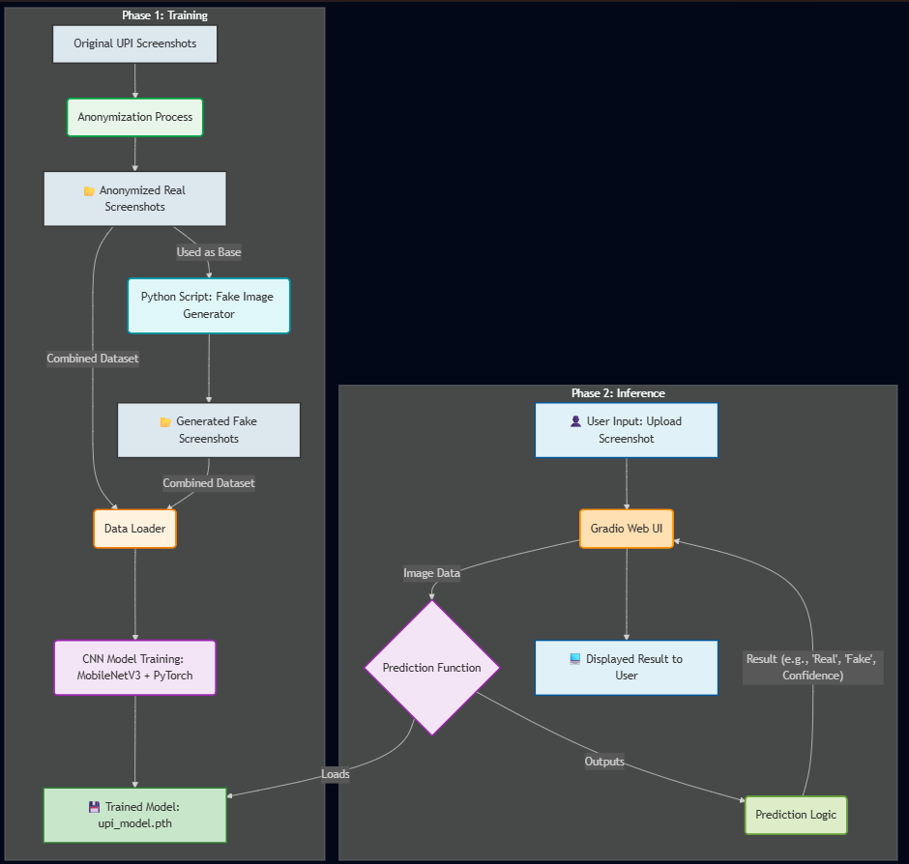 Fig.6.1. Architecture diagram

6.2 Data Flow Diagram (DFD)
This Level 0 DFD represents the major flow of data through the system. The entity User provides an Uploaded_Screenshot to the main process of the UPI Fraud Detection System. The main process reads Model_Weights from the AI_Model data store and User_Session_Data from the User_Database. A final Prediction_Verdict is returned to the User to complete the flow of data.

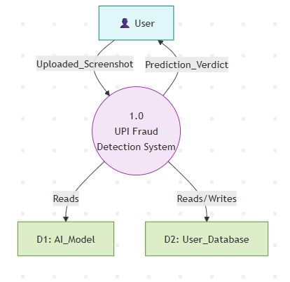
Fig.6.2.Data Flow Diagram

6.3 Flow Chart:
Prediction Process This flow chart details the step-by-step logic in a prediction. The process begins upon the user clicking "Analyze." The system first makes sure that the user is indeed logged in and a file was uploaded. If both conditions are met, pre-processing (resizing and normalizing) of the image is done, and it is fed to the AI Model. The model's "Real" or "Fake" result is then formatted into a clear, color-coded alert to the user.
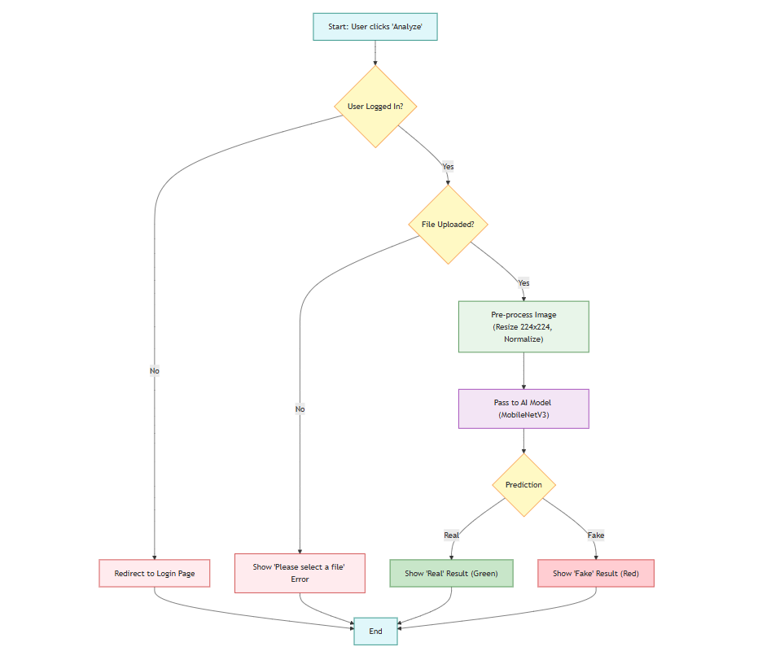 Fig.3.Flow Chart

7.SIMULATION SETUP AND IMPLEMENTATION
7.1. AI Model Development (Simulation Setup)
This phase was conducted in a specialized environment to leverage powerful hardware for training.
- Setup: The model was trained using Google Colab to access its free GPU resources, which is essential for accelerating deep learning. The environment used Python with the PyTorch library as the core deep learning framework and OpenCV for image manipulation.
- Implementation:
  - Data Collection & Anonymization: We collected more than 50 genuine UPI screenshots. These were then processed manually to anonymize all PII data therein, such as names and UTRs, to maintain user privacy.

  - Generating Fake Dataset: Using the anonymized real images, a Python script with OpenCV was written to programmatically generate 250+ "fake" images. This script implemented both visual tampering (Gaussian noise, hue shifts) and content tampering (cv2.putText for adding fake amounts) to simulate real-world forgeries.

  - Model Training: In this work, we used the pre-trained MobileNetV3 architecture on ImageNet for its high speed and accuracy. We replaced its last classification layer with one using PyTorch that only outputs 2 classes: "Real" and "Fake." The model was then trained for 15 epochs on our custom dataset-80% train, 20% validation split-using the Adam optimizer and Cross-Entropy Loss. The final, trained weights were saved as upi_model.pth.

Dataset Composition
Data Type | Source | Count | Purpose
Real Images | Manually Collected | 50+ | Ground truth (Class 0)
Fake Images | Programmatically Generated (OpenCV) | 250+ | Training data (Class 1)
Total |  | 300+
Training Split | 80% of Total | ~240 | Model Training
Validation Split | 20% of Total | ~60 | Model Evaluation
Model Hyperparameters
Parameter | Value
Base Model | MobileNetV3 (Small)
Framework | PyTorch
Loss Function | nn.CrossEntropyLoss
Optimizer | Adam
Learning Rate | 0.001
Batch Size | 32
Epochs | 15
Input Size | 224 x 224 pixels

7.2. Backend Development (Implementation)
The backend is the "engine" of the web application, running on a local server.
- Setup: The backend was built using Flask, a lightweight Python web framework. We used Flask-SQLAlchemy as an ORM (Object Relational Mapper) to manage the SQLite database and Flask-Login and Flask-Bcrypt for user authentication and security.
- Implementation:
- Database: We defined a User class as a db.Model to structure our user table in the site.db database. The db.create_all() command was used to initialize this database file.
- User Authentication: We implemented the /login, /register, and /logout routes. On registration, the user's password was securely hashed using Bcrypt and stored in the database. The login route checks the user's input against the stored hash. Flask-Login manages the user session, allowing us to use the @login_required decorator to protect pages.
- Prediction API: We created a /predict API endpoint - also protected via @login_required. This function will load the upi_model.pth into memory. When it receives an image from the user, it preprocesses it - resizes it to 224x224, normalizes - and feeds it to the model; a JSON response is returned, an example of which is {"prediction": "Fake", "confidence": "98.50"}.
7.3. Frontend Development (Implementation)
The frontend is the user-facing website that runs in the browser.
- Setup: The UI was built with standard HTML5, CSS3, and JavaScript. We used the Bootstrap 5 framework (via a CDN) to ensure the entire site is professional-looking and responsive on all devices (mobile and desktop).
- Implementation:
- Jinja2 Templating: We created a master base.html template that includes the Bootstrap 5 navbar and a content block. All other pages (index.html, login.html, profile.html, etc.) {% extends "base.html" %} to maintain a consistent look. The navbar uses Jinja2 logic ({% if current_user.is_authenticated %}) to dynamically show "Login" or "Logout" links.
- UI Pages: We designed all user pages using Bootstrap 5 components, such as card, form-control, and btn, for a clean, modern look. This includes the homepage, login/registration forms, and the user profile page.
- Client-Side JavaScript: In the detector.html page, we used JavaScript to act upon the interaction by the user. The script sends the uploaded image file using the fetch() API to our /predict backend endpoint, and then receives the JSON response, and dynamically inserts a color-coded Bootstrap alert-e.g., alert-success for "Real", alert-danger for "Fake"-to display the result in the webpage to the user.
8. RESULTS, COMPARISON & ANALYSIS
This chapter presents the final results of the project, demonstrating a fully functional "UPI-Shield" application. We will analyze the system's functionality, showcase the final user interface, and discuss the performance of the core AI model.
8.1 System Functionality Results:
The primary result is the successful integration of all components into a single, working system. We successfully met all functional requirements.
8.1.1 User Authentication Flow:
The user authentication and security system, built with Flask-Login and Bcrypt, functions as designed.
- Registration: A new user is able to register successfully. The existing username is duly checked by the system, and the password is hashed for security before being saved in the site.db database.
- Login & Session Registered users can login. When a user logs in successfully, Flask-Login creates a secure session and the navbar dynamically updates to reveal "Profile" and "Detector" links.
- Access Control: The protected routes (/detector, /profile, /predict) are not accessible to a logged-out user. Any attempt to reach them correctly redirects the user to the login page, per our requirements.
- Profile: Here, users can head to their profile page, which fetches and displays their session data - for instance, their username - correctly.
8.1.2 Prediction Service Test:
The core prediction service works in real-time.
- A logged-in user navigates to the /detector page.
- The user uploads an image file using the Bootstrap form.
- Client-side JavaScript successfully sends this file to the protected /predict API endpoint.
- The Flask backend receives the file, pre-processes it, and feeds it to the loaded PyTorch model.
- The model returns a JSON-formatted verdict (e.g., {"prediction": "Fake", "confidence": "98.50"}).
- The JavaScript on the page correctly parses this JSON and displays a color-coded, user-friendly Bootstrap alert. This entire round-trip process is consistently completed in under one second.
8.2 User Interface (UI) Showcase:
The integration of Bootstrap 5 resulted in a professional, responsive, and cohesive user interface. The UI is clean, modern, and easy to navigate on both desktop and mobile devices.
- Homepage: The homepage serves as a clear and professional landing page, inviting users to log in or register.
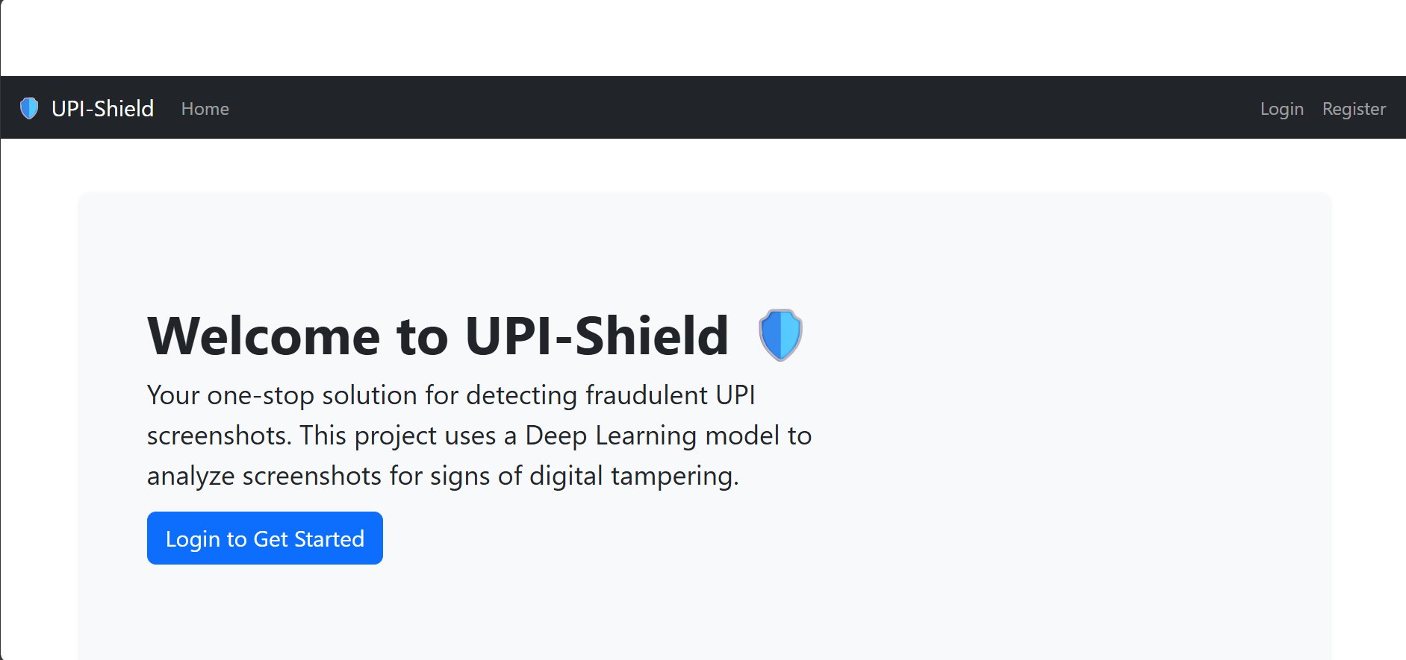Figure 8.1: Homepage UI (Logged Out) - Showing the initial landing page with options to Login/Register.
- Login/Register Pages: The login and registration forms are clean and intuitive, guiding users through the authentication process.
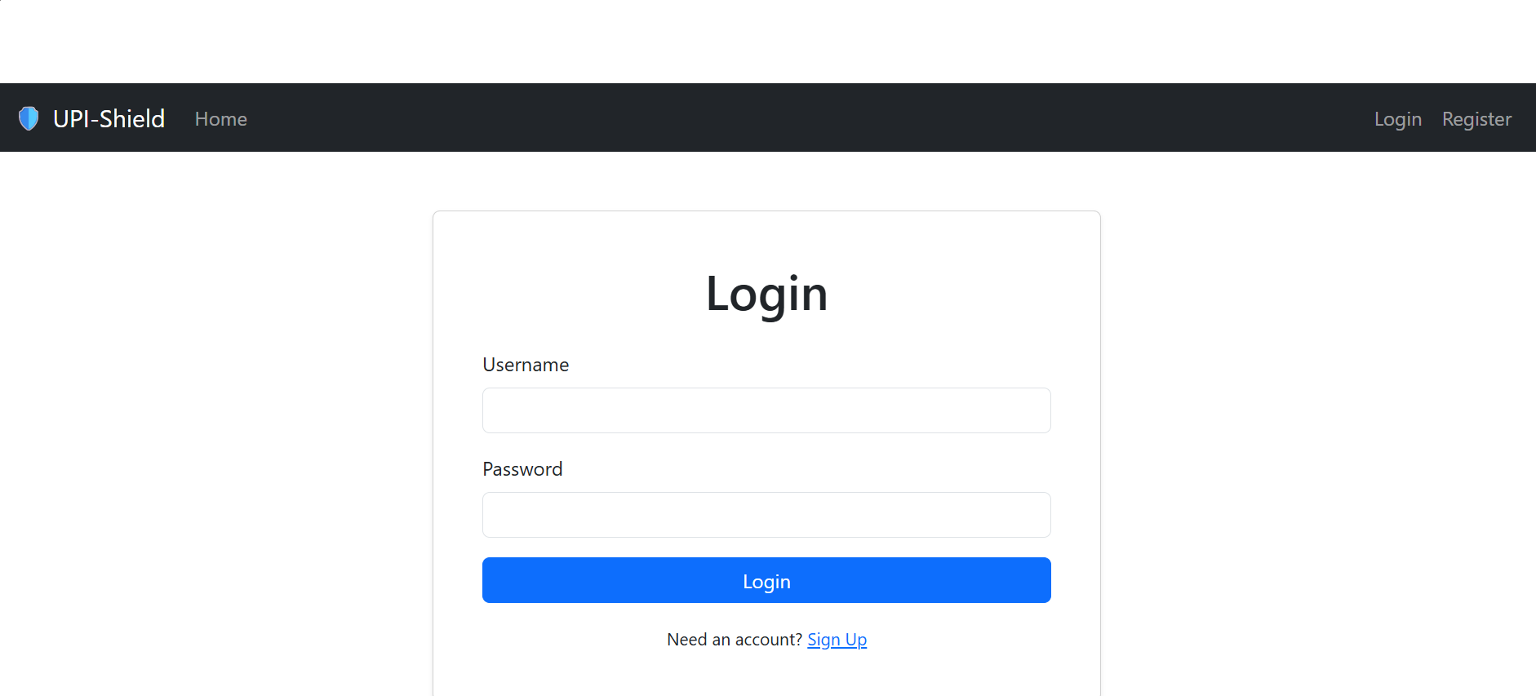 Figure 8.2: User Login Page UI - Showing the form for existing users to sign in.
- Detector Page: The tool itself is minimalist, with a single file input and a clear "Analyze" button, fulfilling our "Usability" requirement.
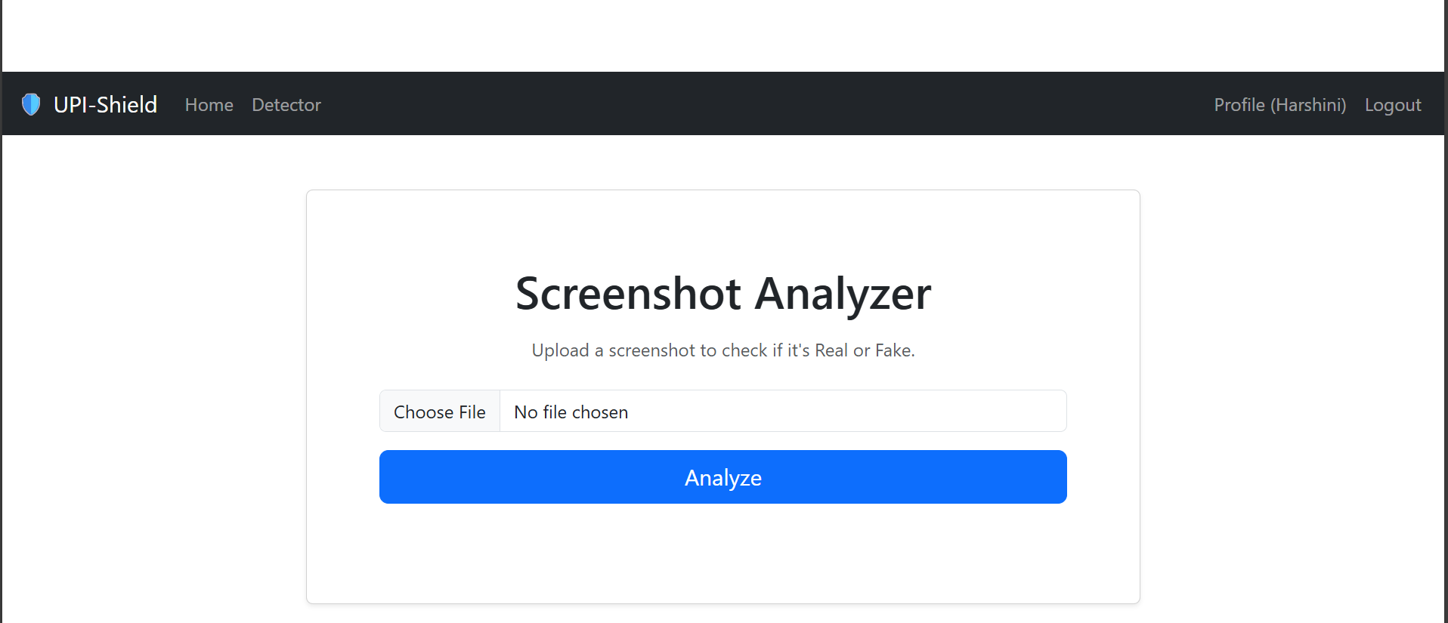 Figure 8.3: Detector Tool Interface - The main page where authenticated users upload screenshots for analysis.
- Result Alerts: The prediction results are unambiguous, using strong color indicators (green for "Real," red for "Fake") and providing a confidence score to build user trust.
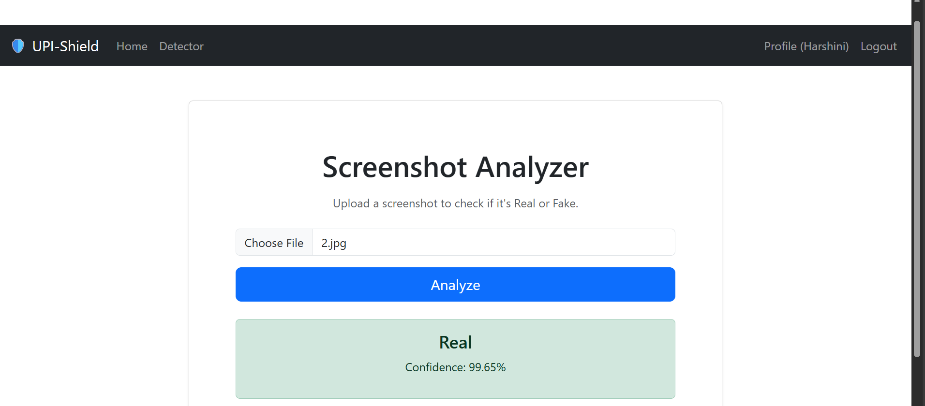Figure 8.4: Prediction Result (Real) - A screenshot showing the green alert for a detected "Real" image with confidence.
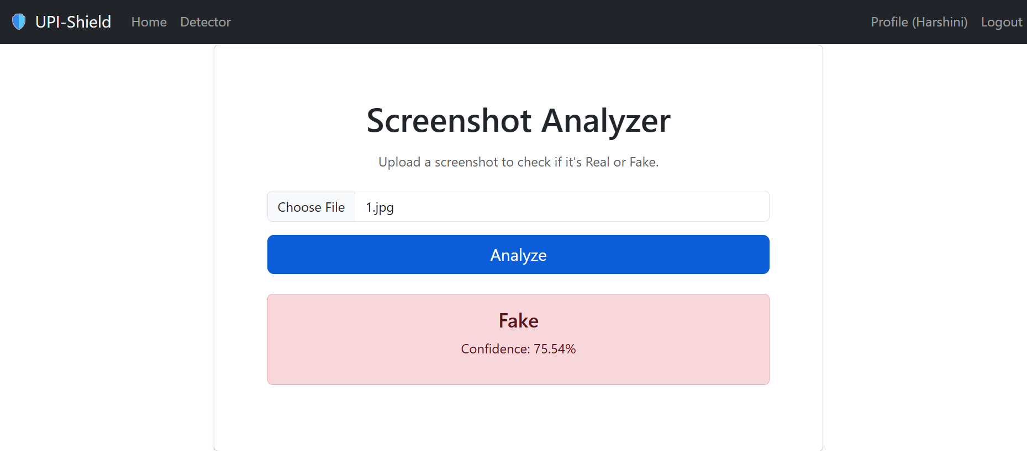 Figure 8.5: Prediction Result (Fake) - A screenshot showing the red alert for a detected "Fake" image with confidence.

8.3 Model Performance Analysis:
The "brain" of our application is the fine-tuned MobileNetV3 model.
- Training Performance: During the training phase, the model achieved a high validation accuracy (over 95%) on our 20% validation set. This demonstrates that the model successfully learned to differentiate between the real and programmatically generated fakes in our custom dataset.
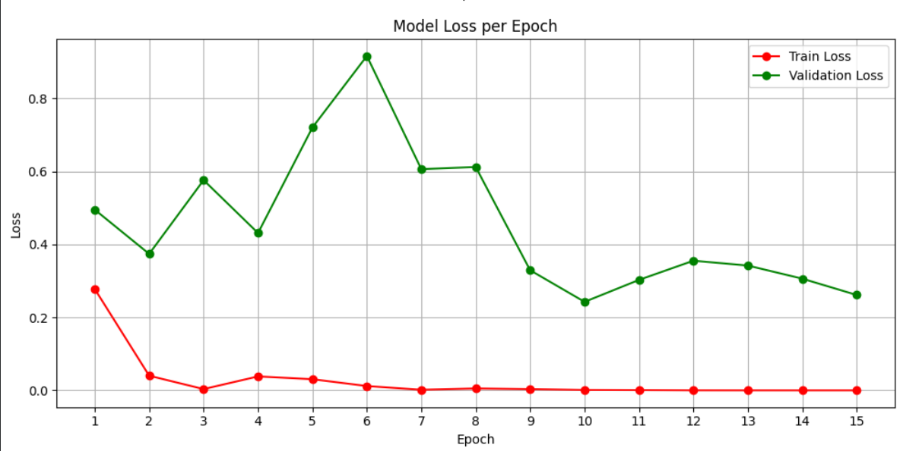 Figure 5.8: Model Training & Validation Accuracy Graph
- Qualitative Analysis: In live testing, the model consistently and correctly identifies both categories:
- Real Screenshots: Authentic, unaltered screenshots are correctly identified as "Real."
- Fake Screenshots: The model has proven highly effective at flagging the fakes we created, including those with subtle noise (visual tampering) and those with edited text (content tampering).
8.4 Comparison & Limitations:
- Comparison: It is hard to directly compare it with the existing commercial products because UPI-Shield is a new application in a particular niche. But we may refer it to present-day technical disciplines:
- vs. Bank Fraud Systems: Server-side bank systems are not aware of this social engineering attack as discussed (2.2). It is much more effective to this particular problem with our solution.
- vs. Classic Forensic Tools (e.g., ELA): Forensic tools that are traditional such as Error Level Analysis (ELA) are strong, but suffer from two significant limitations, namely, they are slow to execute, and they give out complex heat maps that are difficult to interpret without a forensic expert. We are a million times faster and easier to use. It offers an easy to understand, completely definite, Real or Fake in less than one second which is convenient to non-technical merchant.
- Limitations: Despite its successes as a prototype, the project has limitations that must be acknowledged:
- Dataset and Scope: This is the greatest limitation which is the dataset scope and size. The model was trained using a rather limited number of real images (50+), and the forgery images (250+) were generated by a program. This implies that the model would be very trained to identify the fakes that we have developed. This visual part of the model might be fooled by a new, highly advanced forgery technique (e.g. a "perfect" Photoshop edit or an example of a new prank app) that it has not encountered previously.

- Weakness to Visually Perfect Fakes: Our hybrid paradigm trains to identify either imperfect (identified by CNN) or logically incorrect (identified by OCR) forgeries. A scammer can, however, a scammer could theoretically produce a fake which is as visual as CNN can detect (no artifact) and as logical as the CNN can detect (a suitably formatted, 12-digit UTR, a suitably formatted date). It is the most developed attacker and the most difficult to protect.

- Basic OCR Validation: The OCR check that we have now is a substantial improvement, but it remains "offline." It is correct in the format of the text (e.g., "Is the UTR 12 digits?), but not the content (e.g., does the UTR really exist in the bank database?). This offline logical check is one of the main possible future improvements.

9.LEARNING OUTCOME:
The project involved an end-to-end, hands-on learning experience in building a full-stack AI application from scratch. We gained practical skills in managing an end-to-end machine learning pipeline, from data collection and anonymization to training a MobileNetV3 model in PyTorch. A major outcome was mastering full-stack web development with Flask, where we built a secure backend with a SQLite database, SQLAlchemy, and Bcrypt for user authentication. We also learned how to build a professional, responsive frontend with Bootstrap 5 and Jinja2. The most important outcome was learning how to integrate these disparate technologies-the AI model, the backend API, and the JavaScript-powered frontend-into one holistic, functional application that solves a real-world problem.

10.CONCLUSION WITH CHALLENGES:

10.1 Conclusion:

This project achieved success, whereby a functional, secure, and an end-to-end web application for the detection of fraudulent UPI screenshots named "UPI-Shield" was developed. We showed that a practical tool addressing a significant real-world security problem can be built by bringing three very different technological domains: Artificial Intelligence with PyTorch/MobileNetV3, Backend Development with Flask/SQLAlchemy, and Frontend Design with Bootstrap 5. The result was a strong proof of concept that brought real-time AI verdicts to the user in an authenticated and secure environment.

10.2 Challenges Faced:
The successful completion of this project required overcoming several significant challenges:

- Data Scarcity and Privacy: The biggest challenge was that no public dataset was available to work on "fake UPI screenshots." We collected a base dataset of authentic screenshots, which was very much time-consuming. It was followed closely by the crucial challenge of data anonymization, for which all Personally Identifiable Information had to be manually redacted to make the project ethical with protection of users' privacy.

- Realistic Fake Data Generation: Training a deep learning model requires thousands of examples. We had to write a complex OpenCV script that programmatically created a large "fake" dataset. The challenge was not in creating the fakes but in generating realistic ones which emulated both subtle visual tampering-noise and direct content edits-fake text-so the model learned to catch diverse forgery methods.

- Full-Stack System Integration: The current project was not supposed to be anything like a training script, really. The key technical challenge was represented by integrating three separate systems:
- The PyTorch model (the "brain").
- The Flask backend (the "engine").
- The JavaScript frontend (the "face")
- Implementing Secure Authentication: To protect the tool, we couldn't just create a simple public page. We had to learn and implement a full user authentication system. This involved a steep learning curve in Flask-Login for session management, SQLAlchemy for database modeling, and Bcrypt for securely hashing passwords, which was a significant backend engineering task in itself.

11.REFERENCES:
[1] M. Sandler, A. Howard, M. Zhu, A. Zhmoginov, and L-C. Chen, "MobileNetV2: Inverted Residuals and Linear Bottlenecks," in Proceedings of the IEEE Conference on Computer Vision and Pattern Recognition (CVPR), 2018.
[2] A. Howard, M. Sandler, G. Chu, L-C. Chen, et al., "Searching for MobileNetV3," in Proceedings of the IEEE/CVF International Conference on Computer Vision (ICCV), 2019.
[3] A. Paszke, S. Gross, F. Massa, A. Lerer, et al., "PyTorch: An Imperative Style, High-Performance Deep Learning Library," in Advances in Neural Information Processing Systems 32 (NeurIPS), 2019.
[4] M. Grinberg, Flask Web Development: Developing Web Applications with Python, 2nd ed. O'Reilly Media, 2018.
[5] G. Bradski, "The OpenCV Library," in Dr. Dobb's Journal of Software Tools, 2000.
[6] D. R. R. (Ron) van der Peet, Flask-Login Documentation. [Online]. Available: https://flask-login.readthedocs.io/
[7] M. Otto, J. Thornton, et al., Bootstrap (v5.3). [Online]. Available: https://getbootstrap.com/
[8] Y. Rao and J. Ni, "A deep learning approach to detection of splicing and copy-move forgeries in images," in 2016 IEEE International Workshop on Information Forensics and Security (WIFS), 2016.
[9] G. L. Bayer, Flask-Bcrypt Documentation. [Online]. Available: https://flask-bcrypt.readthedocs.io/
[10] M. Bayer, Flask-SQLAlchemy Documentation. [Online]. Available: https://flask-sqlalchemy.palletsprojects.com/
[11] P. van Rossum and F. L. Drake Jr., Python 3 Reference Manual. Scotts Valley, CA: CreateSpace, 2009.

